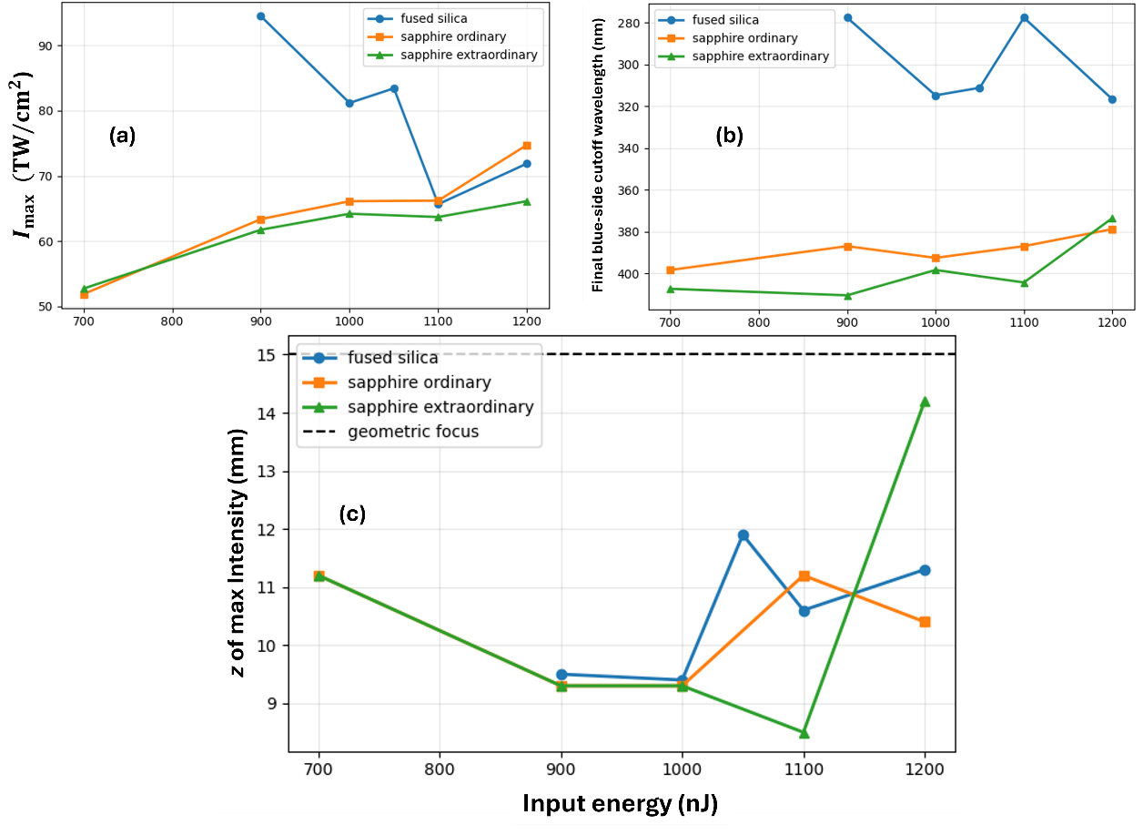
Figure 4. Material comparison of vortex nonlinear propagation. Comparison of focused m=1 vortex propagation in fused silica, ordinary sapphire, and extraordinary sapphire. (a) Maximum intensity as a function of input energy. Fused silica shows stronger nonmonotonic intensity spikes, while sapphire exhibits smoother energy dependence. (b) Final-output blue-side cutoff wavelength. Fused silica reaches substantially shorter cutoff wavelengths, in some cases approaching the numerical bandwidth limit, whereas sapphire remains in the 370–410 nm range. (c) Nonlinear focus position z_{Imax} as a function of input energy. All cases generally collapse before the geometrical focus at 15 mm, shown by the dashed horizontal line. These results demonstrate that sapphire supports vortex-ring breakup and filamentation-like propagation, but with different spectral and focusing behavior from fused silica.

